Department of Computer Science and Engineering
2025-2026
Odd Semester


DATA STRUCTURES AND ALGORITHMS-3
(25CS2103E)

OPTIMAL MATRIX CHAIN MULTIPLICATION

SUGGULA SRI VISHNUPRIYA 2520030348
VUNGARALA MOUKTHIKA 2520030298
DEEPSIKHA BISWAL 2520030205

COURSE INSTRUCTOR

Dr. J Sirisha Devi
Professor
Department of Computer Science and Engineering
OPTIMAL MATRIX CHAIN MULTIPLICATION

Brief description of the case study with examples. Minimum 2-3 pages

Matrix Chain Multiplication is a problem in which a sequence of matrices can be multiplied in different orders. Although the final result remains the same, different multiplication orders can require different numbers of scalar multiplications. Therefore, selecting a suitable multiplication order is important for reducing the overall multiplication cost. The main objective of this case study is to determine the optimal parenthesization of a matrix chain by comparing the costs of different possible multiplication orders.
For example, consider the following three matrices:
- A = 10 × 20
- B = 20 × 30
- C = 30 × 40
These matrices can be multiplied in two different orders:
Case 1: (A × B) × C
First, matrices A and B are multiplied.
Cost = 10 × 20 × 30 = 6000 scalar multiplications.
The resulting matrix has dimensions 10 × 30. This result is then multiplied by matrix C.
Cost = 10 × 30 × 40 = 12000 scalar multiplications.
Therefore, the total cost is:
6000 + 12000 = 18000 scalar multiplications.
Case 2: A × (B × C)
First, matrices B and C are multiplied.
Cost = 20 × 30 × 40 = 24000 scalar multiplications.
The resulting matrix has dimensions 20 × 40. This result is then multiplied by matrix A.
Cost = 10 × 20 × 40 = 8000 scalar multiplications.
Therefore, the total cost is:
24000 + 8000 = 32000 scalar multiplications.
Both multiplication orders produce the same final matrix dimensions, but their scalar multiplication costs are different. In this example, the first order has a lower cost than the second order. This demonstrates why the order of matrix multiplication is important when considering computational cost.
In this project, the program first accepts the number of matrices and their dimensions as input. For a sequence of n matrices, n + 1 dimensions are required. These dimensions are stored in an array and are used to determine the size of each matrix. For example, if the input dimensions are 10, 20, 30, and 40, the matrices are represented as A = 10 × 20, B = 20 × 30, and C = 30 × 40.
The program then generates the possible multiplication orders for the given matrix chain. Each order is evaluated using a cost calculation method. The cost of multiplying two matrices is calculated using the standard matrix multiplication formula:
Cost = rows of the first matrix × columns of the first matrix × columns of the second matrix
The program calculates the total cost of each multiplication order and compares the results. It then identifies the order with the lowest scalar multiplication cost.
The project also implements the Dynamic Programming approach to solve the Matrix Chain Multiplication problem. Dynamic Programming divides the complete problem into smaller subproblems and stores the results of these subproblems in a table. These stored results are then used while calculating the cost of larger groups of matrices. This approach provides a systematic way to determine the minimum multiplication cost.
The program uses a DP cost table in which each entry represents the minimum cost required to multiply a particular range of matrices. For example, the table first considers smaller groups such as A × B and B × C and then uses these results to calculate the minimum cost for A × B × C. The program also uses a split table to store the position at which the matrix chain should be divided for the optimal multiplication order.
Using the split information, the program reconstructs and displays the optimal parenthesization. For the example containing A, B, and C, the program compares (A × B) × C with A × (B × C) and identifies the order having the lower cost. The program also displays the cost of each possible case and the DP cost table, making the calculation and final result easier to understand.
The project is implemented in Java using arrays, loops, conditional statements, methods, and Dynamic Programming tables. The program accepts matrix dimensions as input and displays the corresponding matrices, possible multiplication cases, scalar multiplication costs, DP cost table, optimal parenthesization, and minimum scalar multiplication cost.
Overall, this case study demonstrates how different multiplication orders can result in different computational costs even though they produce the same final matrix result. By comparing the possible orders and applying Dynamic Programming, the program determines the optimal parenthesization and its corresponding minimum cost. The project provides a practical understanding of Matrix Chain Multiplication, Dynamic
Programming, cost calculation, optimal substructure, and the importance of selecting an appropriate multiplication order.
ALGORITHM / PSEUDO CODE
Step-by-step representation of the algorithm/pseudo code in detail. Minimum 2-3 pages
Step 1: Start the Program
- Start the program.
- Create a Scanner object to accept input from the user.
- Display the title of the Matrix Chain Multiplication program.
- Ask the user to enter the number of matrices.
Step 2: Validate the Number of Matrices
- Read the number of matrices and store it in n.
- Check whether n is less than 2.
- If n < 2, display a message stating that at least two matrices are required.
- Stop the program.
- If n >= 2, continue to the next step.
Step 3: Enter Matrix Dimensions
- Create two arrays:
  - rows[] to store the number of rows of each matrix.
  - columns[] to store the number of columns of each matrix.
- For each matrix from A to the last matrix:
  - Ask the user to enter the number of rows.
  - Store the value in rows[].
  - Ask the user to enter the number of columns.
  - Store the value in columns[].
- Display the dimensions of all entered matrices.
For example:
A = 10 × 20
B = 20 × 30
C = 30 × 40
Step 4: Check Matrix Compatibility
Before calculating multiplication orders, check whether consecutive matrices can be multiplied.
- Start from the first matrix.
- Compare the number of columns of the current matrix with the number of rows of the next matrix.
- For matrices A and B, check:
columns[A] = rows[B]
- If they are equal, A and B are compatible for multiplication.
- Continue checking the next pair of matrices.
- Repeat the process until all consecutive matrix pairs have been checked.
- If any pair is incompatible:
  - Display the incompatible matrices.
  - Display their dimensions.
  - Display that Matrix Chain Multiplication cannot be performed.
  - Stop the program.
- If all consecutive pairs are compatible, display that all matrices are compatible and continue.
For example:
A = 10 × 20
B = 20 × 30
Since:
Columns of A = 20
Rows of B = 20
A × B is possible.
Step 5: Generate All Possible Multiplication Orders
- Create an array to store the possible multiplication orders.
- Start from the first matrix and continue until the last matrix.
- Divide the matrix chain at different possible positions.
- Generate the possible orders for the left part.
- Generate the possible orders for the right part.
- Combine the left and right orders using parentheses.
- Store every complete multiplication order in the result array.
For three matrices A, B, and C, the possible orders are:
((A * B) * C)
(A * (B * C))
- Continue the process until all possible parenthesizations have been generated.
Step 6: Calculate the Cost of Each Order
- Take one multiplication order from the generated orders.
- Read the order character by character.
- When a matrix name such as A, B, or C is found:
  - Identify its matrix number.
  - Obtain its row and column dimensions.
  - Store the matrix information temporarily.
- When a closing parenthesis ) is encountered:
  - Take the right matrix or intermediate result.
  - Take the left matrix or intermediate result.
  - Obtain their dimensions and previously calculated costs.
- Calculate the cost of the current multiplication using:
Multiplication Cost =
Rows of Left Matrix
× Columns of Left Matrix
× Columns of Right Matrix
- Add the cost of the left part and the right part to the current multiplication cost.
Total Cost =
Left Cost
+ Right Cost
+ Current Multiplication Cost
- Store the dimensions of the resulting matrix.
- Store the calculated total cost.
- Continue until the complete multiplication order has been evaluated.
- Return the total cost of the order.
For example:
A = 10 × 20
B = 20 × 30
The cost of A × B is:
10 × 20 × 30 = 6000
The result of A × B has dimensions:
10 × 30
Step 7: Compare All Generated Cases
- Set minimumCost to the largest possible integer value.
- Set bestOrder as empty.
- Take each generated multiplication order one by one.
- Calculate its total scalar multiplication cost.
- Display the case number.
- Display the multiplication order.
- Display its calculated cost.
- Compare the current cost with minimumCost.
- If the current cost is smaller:
  - Update minimumCost.
  - Store the current order in bestOrder.
- Continue until every generated multiplication order has been checked.
At the end of this step, the program has identified the multiplication order having the lowest calculated cost among the generated cases.
Step 8: Initialize Dynamic Programming
- Create a two-dimensional DP table called dp.
- Create a two-dimensional split table.
- The dp table stores the minimum multiplication cost for different ranges of matrices.
- The split table stores the position at which the matrix chain should be divided to obtain the corresponding minimum cost.
- For a single matrix, no multiplication is required.
Therefore:
dp[i][i] = 0
Step 9: Calculate the DP Table
- Start with a chain containing two matrices.
- Increase the chain length one by one until the complete matrix chain is considered.
- For each chain length, determine the starting position i.
- Calculate the ending position j.
- Initially set:
dp[i][j] = Maximum Integer Value
- Try every possible split position k between i and j.
- Calculate the cost for the current split using:
Current Cost =
dp[i][k]
+
dp[k+1][j]
+
rows[i]
× columns[k]
× columns[j]
- Compare the current cost with the value already stored in dp[i][j].
- If the current cost is smaller:
  - Update dp[i][j].
  - Store k in split[i][j].
- Continue checking all possible split positions.
- After all split positions have been checked, dp[i][j] contains the minimum cost for that matrix range.
- Continue until the DP table for the complete matrix chain has been calculated.
Step 10: Construct the Optimal Parenthesization
- Use the split table to find the best division point.
- Start with the complete matrix chain.
- Check the split position stored for the current range.
- Recursively process the left part.
- Recursively process the right part.
- Place a multiplication operator between the two parts.
- Add parentheses around the combined result.
- Continue until individual matrices are reached.
- Display the resulting optimal parenthesization.
For example:
((A * B) * C)
represents the selected multiplication order.
Step 11: Display the DP Table
- Display the DP cost table.
- Display the matrix names as row and column headings.
- Display the calculated minimum costs for the different matrix ranges.
- Display - where a value is not applicable.
- The diagonal values represent individual matrices and have a cost of zero.
- The final entry corresponding to the complete matrix chain represents the minimum scalar multiplication cost obtained using Dynamic Programming.
Step 12: Display the Final Results
- Display the optimal parenthesization obtained from the DP split table.
- Display the minimum scalar multiplication cost.
- Display the total number of matrices.
- Display the number of possible multiplication cases generated.
- Display the best order obtained from the generated cases.
- Display the minimum cost obtained from comparing the generated cases.
- Display the optimal cost obtained through Dynamic Programming.
- Close the Scanner.
- End the program.

CODE
import java.util.Scanner;
public class OptimalMatrixChain {
// ---------------------------------------------------------
// Calculate the cost of one particular multiplication order
// ---------------------------------------------------------
static int calculateCost(int[] rows, int[] columns, String order) {
int[] resultRows = new int[100];
int[] resultColumns = new int[100];
int[] costs = new int[100];
int top = -1;
for (int i = 0; i < order.length(); i++) {
char ch = order.charAt(i);
// If the character represents a matrix
if (ch >= 'A' && ch <= 'Z') {
int matrixNumber = ch - 'A';
top++;
resultRows[top] = rows[matrixNumber];
resultColumns[top] = columns[matrixNumber];
costs[top] = 0;
}
// When a closing bracket is found,
// multiply the two sub-results
else if (ch == ')') {
int rightRows = resultRows[top];
int rightColumns = resultColumns[top];
int rightCost = costs[top];
top--;
int leftRows = resultRows[top];
int leftColumns = resultColumns[top];
int leftCost = costs[top];
// Cost of multiplying two matrices
int multiplicationCost =
leftRows * leftColumns * rightColumns;
int totalCost =
leftCost
+ rightCost
+ multiplicationCost;
// Store the resulting matrix
resultRows[top] = leftRows;
resultColumns[top] = rightColumns;
costs[top] = totalCost;
}}
return costs[top];
}
// ---------------------------------------------------------
// Generate all possible parenthesizations
// ---------------------------------------------------------
static void generateOrders(
int start,
int end,
String[] result,
int[] count) {
// Only one matrix
if (start == end) {
result[count[0]] = getMatrixName(start);
count[0]++;
return;
}
// Try every possible splitting point
for (int k = start; k < end; k++) {
String[] leftOrders = new String[10000];
String[] rightOrders = new String[10000];
int[] leftCount = {0};
int[] rightCount = {0};
generateOrders(
start,k,leftOrders,leftCount);
generateOrders(
k + 1,
end,
rightOrders,
rightCount
);
// Combine all left and right possibilities
for (int i = 0; i < leftCount[0]; i++) {
for (int j = 0; j < rightCount[0]; j++) {
result[count[0]] =
"("
+ leftOrders[i]
+ " * "
+ rightOrders[j]
+ ")";
count[0]++;
}
}
}
}
// ---------------------------------------------------------
// Generate matrix name
// ---------------------------------------------------------
static String getMatrixName(int number) {
if (number < 26) {
char name = (char) ('A' + number);
return String.valueOf(name);
}
return "A" + number;
}
// ---------------------------------------------------------
// Dynamic Programming algorithm
// ---------------------------------------------------------
static int[][] dynamicProgramming(
int[] rows,
int[] columns,
int n,
int[][] split) {
int[][] dp = new int[n + 1][n + 1];
// length = number of matrices in the chain
for (int length = 2; length <= n; length++) {
for (int i = 1; i <= n - length + 1; i++) {
int j = i + length - 1;
// Initially set to maximum value
dp[i][j] = Integer.MAX_VALUE;
// Try every possible split
for (int k = i; k < j; k++) {
int currentCost =
dp[i][k]
+ dp[k + 1][j]
+ rows[i - 1]
* columns[k - 1]
* columns[j - 1];
// Store the minimum cost
if (currentCost < dp[i][j]) {
dp[i][j] = currentCost;
split[i][j] = k;
}
}
}
}
return dp;
}
// ---------------------------------------------------------
// Print optimal parenthesization
// ---------------------------------------------------------
static void printOptimalOrder(
int[][] split,
int i,
int j) {
if (i == j) {
System.out.print(getMatrixName(i - 1));
return;
}
System.out.print("(");
printOptimalOrder(
split,
i,
split[i][j]
);
System.out.print(" * ");
printOptimalOrder(
split,
split[i][j] + 1,
j
);
System.out.print(")");
}
// ---------------------------------------------------------
// Print DP cost table
// ---------------------------------------------------------
static void printDPTable(
int[][] dp,
int n) {
System.out.println();

System.out.println(
"======================================================"
);

System.out.println(
" DP COST TABLE"
);

System.out.println(
"======================================================"
);

System.out.println();

System.out.print(" ");

for (int i = 1; i <= n; i++) {

System.out.printf(
"%10s",
getMatrixName(i - 1)
);
}

System.out.println();

for (int i = 1; i <= n; i++) {

System.out.printf(
"%5s",
getMatrixName(i - 1)
);

for (int j = 1; j <= n; j++) {

if (j < i) {

System.out.printf(
"%10s",
"-"
);

} else {

System.out.printf(
"%10d",
dp[i][j]
);
}
}

System.out.println();
}
}

// ---------------------------------------------------------
// MAIN METHOD
// ---------------------------------------------------------
public static void main(String[] args) {

Scanner sc = new Scanner(System.in);

System.out.println(
"======================================================"
);

System.out.println(
" OPTIMAL MATRIX CHAIN MULTIPLICATION"
);

System.out.println(
"======================================================"
);

// -----------------------------------------------------
// STEP 1: Number of matrices
// -----------------------------------------------------

System.out.print(
"\nEnter the number of matrices: "
);

int n = sc.nextInt();

// Check minimum number of matrices
if (n < 2) {
System.out.println(
"Please enter at least 2 matrices."
);
sc.close();
return;
}
// -----------------------------------------------------
// STEP 2: Create rows and columns arrays
// -----------------------------------------------------
int[] rows = new int[n];
int[] columns = new int[n];
// -----------------------------------------------------
// STEP 3: Enter rows and columns
// -----------------------------------------------------
System.out.println();
System.out.println(
"======================================================"
);
System.out.println(
" ENTER MATRIX DIMENSIONS"
);
System.out.println(
"======================================================"
);

System.out.println();

System.out.println(
"Enter the rows and columns of each matrix separately."
);

System.out.println();

for (int i = 0; i < n; i++) {

System.out.println(
"Matrix " + getMatrixName(i)
);

System.out.print("Enter number of rows: ");
rows[i] = sc.nextInt();

System.out.print("Enter number of columns: ");
columns[i] = sc.nextInt();

System.out.println();
}

// -----------------------------------------------------
// STEP 4: Display entered matrices
// -----------------------------------------------------

System.out.println();

System.out.println(
"======================================================"
);

System.out.println(
" ENTERED MATRICES"
);

System.out.println(
"======================================================"
);

System.out.println();

for (int i = 0; i < n; i++) {

System.out.println(
getMatrixName(i)
+ " = "
+ rows[i]
+ " x "
+ columns[i]
);
}

// -----------------------------------------------------
// STEP 5: Check matrix compatibility
// -----------------------------------------------------

System.out.println();

System.out.println(
"======================================================"
);

System.out.println(
" CHECKING COMPATIBILITY"
);

System.out.println(
"======================================================"
);

System.out.println();

boolean possible = true;

for (int i = 0; i < n - 1; i++) {

System.out.println(
"Checking "
+ getMatrixName(i)
+ " x "
+ getMatrixName(i + 1)
+ "..."
);

System.out.println(
"Columns of "
+ getMatrixName(i)
+ " = "
+ columns[i]
);

System.out.println(
"Rows of "
+ getMatrixName(i + 1)
+ " = "
+ rows[i + 1]
);

if (columns[i] == rows[i + 1]) {

System.out.println(
"Result: COMPATIBLE"
);

} else {

System.out.println(
"Result: NOT COMPATIBLE"
);

System.out.println();

System.out.println(
"Matrix multiplication is NOT possible."
);

System.out.println(
"Columns of "
+ getMatrixName(i)
+ " ("
+ columns[i]
+ ") must be equal to rows of "
+ getMatrixName(i + 1)
+ " ("
+ rows[i + 1]
+ ")."
);

possible = false;

break;
}

System.out.println();
}

// -----------------------------------------------------
// STEP 6: Stop if multiplication is not possible
// -----------------------------------------------------

if (!possible) {

System.out.println(
"Program stopped because the matrices are incompatible."
);

sc.close();

return;
}

// -----------------------------------------------------
// STEP 7: All matrices are compatible
// -----------------------------------------------------

System.out.println(
"======================================================"
);

System.out.println(
" ALL MATRICES ARE COMPATIBLE"
);

System.out.println(
"======================================================"
);

System.out.println();

System.out.println(
"Matrix Chain Multiplication can be performed."
);

// -----------------------------------------------------
// STEP 8: Generate all possible multiplication cases
// -----------------------------------------------------

String[] orders = new String[100000];

int[] count = {0};

generateOrders(
0,
n - 1,
orders,
count
);

// -----------------------------------------------------
// STEP 9: Display all possible cases and their costs
// -----------------------------------------------------

System.out.println();

System.out.println(
"======================================================"
);

System.out.println(
" ALL POSSIBLE MULTIPLICATION CASES"
);

System.out.println(
"======================================================"
);

int minimumCost = Integer.MAX_VALUE;

String bestOrder = "";

for (int i = 0; i < count[0]; i++) {

String order = orders[i];

int cost =
calculateCost(
rows,
columns,
order
);

System.out.println();

System.out.println(
"Case " + (i + 1)
);

System.out.println(
"Order : " + order
);

System.out.println(
"Cost : "
+ cost
+ " scalar multiplications"
);

// Find minimum cost
if (cost < minimumCost) {

minimumCost = cost;

bestOrder = order;
}
}

// -----------------------------------------------------
// STEP 10: Dynamic Programming
// -----------------------------------------------------

int[][] split =
new int[n + 1][n + 1];

int[][] dp =
dynamicProgramming(
rows,
columns,
n,
split
);

// -----------------------------------------------------
// STEP 11: Display DP table
// -----------------------------------------------------

printDPTable(
dp,
n
);

// -----------------------------------------------------
// STEP 12: Display optimal result
// -----------------------------------------------------

System.out.println();

System.out.println(
"======================================================"
);

System.out.println(
" OPTIMAL RESULT"
);

System.out.println(
"======================================================"
);

System.out.println();
System.out.println(
"Optimal Parenthesization:"
);
printOptimalOrder(
split,
1,
n
);
System.out.println();
System.out.println();
System.out.println(
"Minimum Scalar Multiplications: "
+ dp[1][n]
);

// -----------------------------------------------------
// STEP 13: Final summary
// -----------------------------------------------------

System.out.println();
System.out.println(
"======================================================"
);

System.out.println(
" SUMMARY"
);

System.out.println(
"======================================================"
);

System.out.println();

System.out.println(
"Number of matrices : " + n
);

System.out.println(
"Number of possible cases : "
+ count[0]
);
System.out.println(
"Best order from cases : "
+ bestOrder
);

System.out.println(
"Minimum cost : "
+ minimumCost
);

System.out.println(
"DP optimal cost : "
+ dp[1][n]
);

System.out.println();

System.out.println(
"======================================================"
);

System.out.println(
" PROGRAM COMPLETED"
);

System.out.println(
"======================================================"
);
sc.close();
}
}

RESULTS
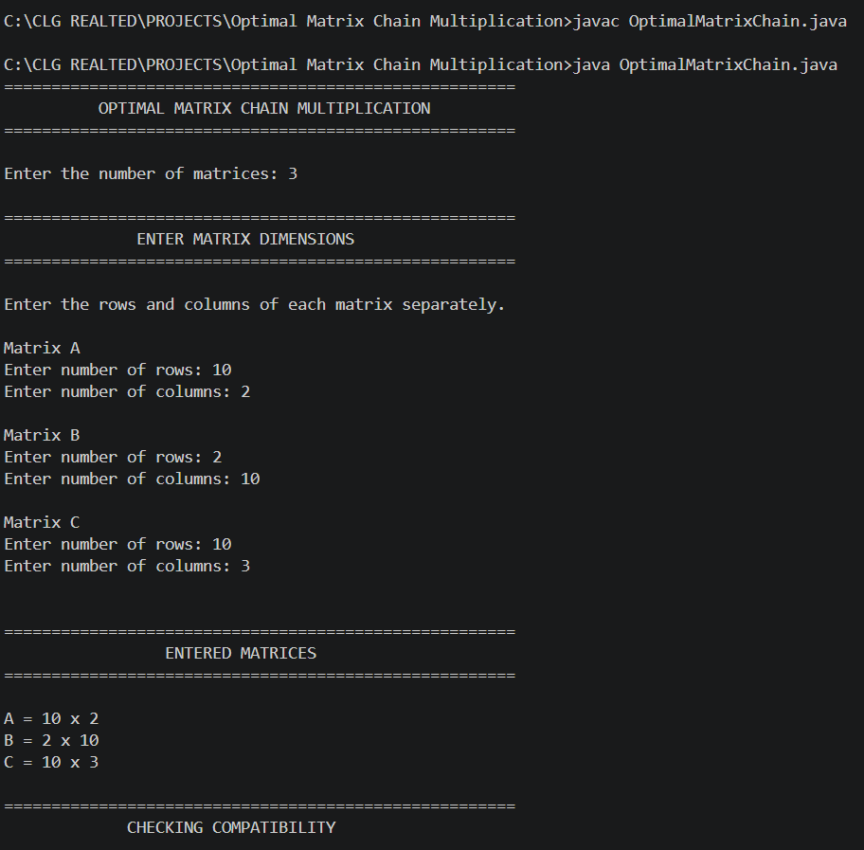
Screenshots

